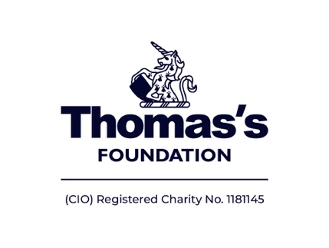

Music Scholarships for Young Musicians

Thomas’s Foundation (TF) is pleased to offer music scholarships for young musicians who demonstrate significant musical potential and commitment, but for whom financial constraints create a barrier to ongoing study.

The scheme award guarantees funding for up to 4 years for:
- Sustained high quality instrumental tuition delivered by the Tri-borough Music Hub (TBMH) at their Saturday Music School
- Participation in a music ensemble (if applicable);
- Access to resources including instrument (if required), sheet music and exam fees;
- Performance opportunities; and
- A named mentor who liaises between the scholar and family, the music hub and TF.

Eligibility Criteria

- The cost of ongoing tuition and instrument hire is prohibitive for the family.
- The child is a student in Years 3- 6, attending a school in RB Kensington and Chelsea or LB Hammersmith and Fulham.
- The child demonstrates particular musical talent and clear commitment to their own musical development.
- The child’s parent/carer commits to actively support the child in all aspects of the scholarship programme. This includes ensuring regular practice, weekly attendance at lessons and ensembles and making a £10.00 enrolment contribution per year.

Nomination Process
Our open nomination process invites head teachers, music coordinators, instrumental teachers and other music education professionals to nominate students for a scholarship.
If short-listed, children and their parents/carers will be expected to send in a pre-recorded audition video.

Applications must be received by: May 2024
Please send applications to Emily Hall at Emily.Hall@rbkc.gov.uk copying in info@triboroughmusichub.org

Auditions for short-listed applicants
You will be contacted about preparing a pre-recorded video audition after May half term. It is likely you will have approximately 2 weeks to prepare an audition video.

For successful applicants, tuition will commence in the Autumn Term 2024.

Information about Thomas's Foundation can be found at www.thomassfoundation.org.uk
Lucy van Straubenzee, Thomas’s Foundation Community Partnerships Director.
lvanstraubenzee@thomassfoundation.org.uk
Thomas’s Foundation Music Scholarship Nomination Form - 2024

Name of child (in capitals):
Name of school:
Date of Birth: | Male/Female | Ethnicity:
Does the student have a disability or special educational need?

Does the student qualify for Free School Meals? |  | YES/ NO
We would like to include photographs of auditions / concerts in TF newsletters and website. Do you agree your child’s image may be used? |  | YES/ NO

Section 1 – to be completed by the instrumental / music teacher

What instrument does the child play?

How long has the student been learning? | (months/years)
Does the child learn in a small group or whole class setting?

Will the student need to borrow an instrument?
Student’s playing ability

Details of level of musical ability: e.g. “good aural response, in ensemble can follow cues and has strong sense of pulse”

Details of technical skills achieved: e.g. “competent at using open strings and first finger”

Details of level of Musical theory knowledge: e.g. “understands simple note values and reading of pitches C - G”

Details of student’s commitment: e.g. participation in extracurricular music activities.

Name of instrumental/music teacher (capitals):

Signature instrumental/music teacher: Date:

Section 2 – to be completed by the Head teacher

As far as you know, do you believe that the cost of ongoing musical tuition and instrument hire could be prohibitive for this family?
YES / NO

Do you consider the nominated student to have the following attributes for the award?

- Commitment to regular attendance at lessons: YES / NO

- Commitment to independent learning and regular practice: YES / NO

If the student is unable to practise at home, would you provide a designated
school practice room (at least three times per week for around 20 minutes)? YES / NO

Would you release the student from school for special rehearsal/performance
days organised by the Music Service (no more than one day per term)? YES /NO

Name of Head teacher (in capitals):………………………………………………………………….

Signature of Head teacher:…………………………..........................Date:…………….....................

Section 3 – to be completed by parent / carer

I agree to the Terms and Conditions of this application and will fully support my child to attend all music activities including lessons, ensemble rehearsals and performances. I commit to making a £10 annual payment if accepted. Parent contact details will be shared with Thomas’s Foundation, if child is awarded a scholarship.

Name of parent/carer (in capitals):……………………………………………………………………

Signature of parent/carer:………………………………………… Date:……………………………

Parent/carer email address:……………………………………………………………………………..

